Experiment -18
NAME: A. Vikranth Reddy
Rg No:192424193
Course Code: DSA0406
Course Name: Fundamentals of Data Science for Data Processing
18. Suppose a hospital tested the age and body fat data for 18 randomly selected adults with the following result.
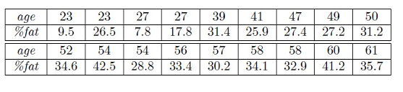Question:
• Calculate the mean, median and standard deviation of age and %fat using Pandas.
• Draw the boxplots for age and %fat.
• Draw a scatter plot and a q-q plot based on these two variables
Code
import pandas as pd
import matplotlib.pyplot as plt
import scipy.stats as stats
age = [23, 23, 27, 27, 39, 41, 47, 49, 50,
52, 54, 54, 56, 57, 58, 58, 60, 61]
fat = [9.5, 26.5, 7.8, 17.8, 31.4, 25.9, 27.4, 27.2, 31.2,
34.6, 42.5, 28.8, 33.4, 30.2, 34.1, 32.9, 41.2, 35.7]
df = pd.DataFrame({
"Age": age,
"%Fat": fat
})
print("Mean Values:")
print(df.mean())
print("\nMedian Values:")
print(df.median())
print("\nStandard Deviation:")
print(df.std())
df.boxplot(column=["Age", "%Fat"])
plt.title("Boxplot of Age and %Fat")
plt.show()
plt.scatter(df["Age"], df["%Fat"])
plt.xlabel("Age")
plt.ylabel("%Fat")
plt.title("Scatter Plot of Age vs %Fat")
plt.show()
stats.probplot(df["Age"], dist="norm", plot=plt)
plt.title("Q-Q Plot for Age")
plt.show()
stats.probplot(df["%Fat"], dist="norm", plot=plt)
plt.title("Q-Q Plot for %Fat")
plt.show()
Output:
